CASCADE 3 Student Internship / Faculty Externship Final Report (Exhibit B)
Date: July 14, 2023
Allan Hancock College (AHC)
Marc Carson, AHC Faculty Externship Lead

A. Outcomes and results:
Name of Student Intern | Hours Worked | Work Experience Credits Earned | Name of the DoD company
- Teresa Gerrity | 120 | 1 | Space Information Laboratories (SIL). Santa Maria, CA
- Flavio Vargas | 120 | 1 | Space Information Laboratories (SIL). Santa Maria, CA

Description of Internship Work:
- Teresa’s internship project at SIL: Autonomous Flight Termination Unit (AFTU)
Teresa’s project consisted of two main tasks: the cybersecurity audit log roadmap and the requirements documentation for the AFTU. She wrote an overview of the cybersecurity problems, requirements, design scope, research and testing, and recommended path forward. She submitted her internship project outputs to the software team for future reference. Teresa also completed a new requirements document focusing on the baseline functionality and the most relevant requirements required by the AFTU customer.
Benefits to SIL and Intern: The audit log document is the roadmap for implementation of the DoD cybersecurity requirements for the AFTU by the software team. Having this information available reduces the time needed for software development in that area. The work Teresa completed on the main requirements document benefited SIL not only because its existence is necessary to prove product specifications but was also completed ahead of schedule.

- Flavio’s internship project at SIL: NIST/Network Compliance
Flavio’s internship project at SIL was to support the implementation of controls required by NIST 800-171 (Cybersecurity Framework / Compliance). SIL's IT department is required to implement various controls on users in the system. After completing initial training and onboarding, Flavio was assigned to research possible changes to satisfy these system controls and to support daily IT tasks.

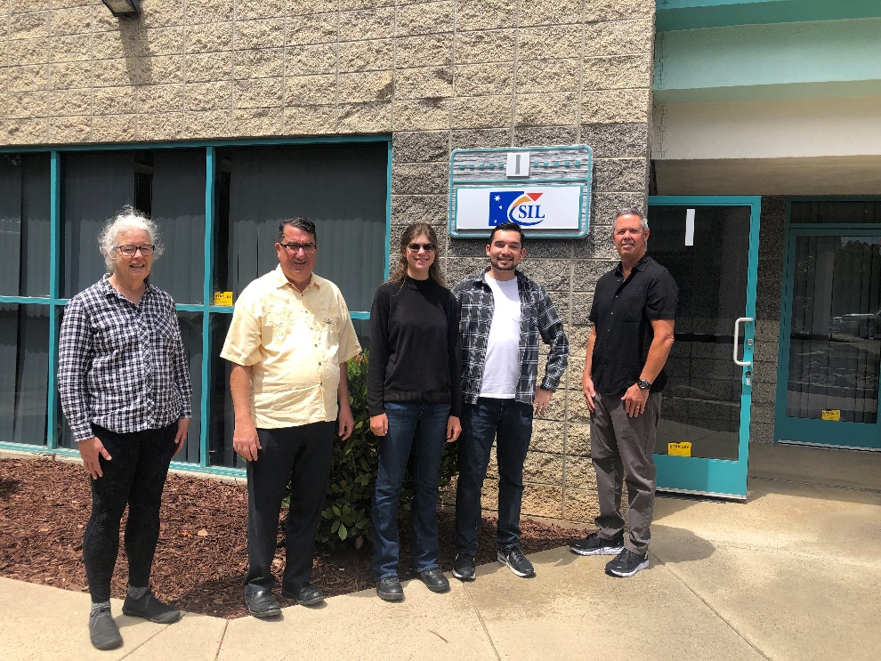
From left to right: Jeanne Cickay (SIL Software Lead), Edmund Burke (SIL President), Teresa Gerrity (Software Eng Intern), Flavio Vargas (Network / Compliance Intern), Marc Carson AHC Faculty Project Lead

B. Describe any benefits derived by the faculty extern/coach from working with the DoD companies and student interns.
The benefits derived by the faculty extern/coach started during the early phase of the company selection process. Initial benefits during the evaluation phase included potential partnerships with local companies from Santa Barbara to San Luis Obispo. Most of these companies were not aware of the CASCADE 3 grant or had considered partnering with the college. Direct benefits include facilitating the two internships and industry partnership which has been established with Space Information Laboratories (SIL) and potential follow-on employment opportunities for the interns. The CASCADE 3 grant process also continued a strategic partnership with Zone 5 Technologies, located in San Luis Obispo. The AHC faculty extern was able to assess local industry cybersecurity requirements, challenges, and resource needs at local DoD companies, like Zone 5 technologies, to further possible industry partnerships. The industry knowledge derived from this process not only benefited the selected two interns but will benefit generations to come through enhanced and expanded industry partnerships and college curriculum expansion.
C. List anecdotal information regarding the success of the student internship/faculty externship project.

The relationships established during the execution of the CASCADE 3 project not only created a partnership between Space Information Laboratories and Allan Hancock College, but also positively impacted other students and businesses. The process established connections that will lead to other student internships and business partnering opportunities for the college.
Input from Teresa Gerrity: The error that was causing data not to be transferred between the DKM (kernel module) and RTP (real-time processor) was an interesting problem. These two entities exist in different memory spaces, so an interface between them had to be coded. This was done using message queues, but there was a consistent problem where the data would have the wrong timestamp associated with it, which would throw an error. It turned out the problem was we were checking for data too often in the message queue, causing the program to grab multiple copies of the same packet with the same timestamp. We resolved this by modifying the sample rate of the message queue, so it had time to be cleared and a new packet received before the program checked the queue for data again. Figuring out how to enable security events was a highlight of the internship. I had spent a couple weeks researching how VxWorks was able to recognize and log security events, and then how to enable the correct modules in our build. Buried in the VSB settings I finally found how to add all the necessary components. VxWorks is supposed to log a security event upon startup, and when we compiled the code and ran it, it immediately printed out a security event message to the terminal.
Input for Flavio Vargas: Something I learned very quickly in the internship is that in the IT space, although time is of the essence, sometimes a situation comes along that you need to drop everything else for. Additional licenses, a more detailed explanation, even a response from a contact or coworker. Sometimes even outside factors, such as an employee leaving the company or going on leave, can heavily impact the task at hand, and what needs to be prioritized. There were multiple times where I needed to drop what I was doing to complete an urgent ticket or fix broken software. This was a great learning experience, however, that the IT line of work is a very busy one that requires skills in multitasking.

D. List any extenuating circumstances that prevented you from completing objectives of the project: There were no issues that impacted the overall completion of this externship / internship project.
Input from Teresa Gerrity: One extenuating circumstance was the prohibitive licensing cost of VxWorks, the operating system used on the AFTU. Only one license was available, which meant only one person was able to code/test on the AFTU at a given time. Everyone on the software team was accommodating and I’m very grateful to have been granted access to work on the code itself when it was available. There were also some issues with file transfer that cropped up from time to time during my internship- files I was supposed to be able to access were no longer available or I could not upload files where they needed to be. This was eventually resolved by IT support.
Input for Flavio Vargas: There were no issues that impacted this project.

E. Describe your three greatest challenges you experienced in completing the internship project:
Teresa Gerrity’s greatest project challenges:
- The biggest challenge by far was learning acronyms and terminology. Everything from requirement documentation to component names to workflow processes has an acronym that is used instead of spelling out the entire name. Participating in meetings, email chains, or reading through documentation for the first few weeks felt like decoding encrypted messages. Only once everything was translated into regular English could I begin to grasp the actual information. The learning curve was steep in that area.
- Another challenging aspect was understanding the operating system they were using, VxWorks. This OS is uniquely suited to running software that must be deterministic (every task must be completed within a pre-defined time frame), and is modular in nature, meaning it can be trimmed down to exactly the amount of OS software support you need. This is useful when you want your software to be as lightweight as possible, as well as reducing risk since any component that is not included in the build cannot break and cause problems. It took a while to get used to this type of OS since it is completely different from standard operating systems, such as Windows or Mac.
- The last significant challenge was learning C++ syntax. I didn’t have much prior experience coding in C++ and learned on the fly about unique aspects of the language. For example, memory allocation in C++ is handled more directly by the user than in other languages. For each object created that is no longer in use, you must programmatically delete it to avoid running out of memory space. Other languages handle garbage collection automatically but this is something you must handle when coding in C++.
Flavio Vargas’ greatest project challenges:
I knew that everything I did here at SIL was going to be a learning experience. There were multiple times where I needed to leave my current task for one of higher priorities, but there was never a situation that arose that did not teach me something new. Towards the end of my internship project, the SIL Employee off- boarding process taught me about the ticket system, and how it’s important to document and keep track of who is performing what task. In the beginning of the internship, I was taught that IT needs to work with other departments in the organization to complete its tasks. Finally, in the last weeks, a firewall project taught me that one change can break an entire computer system environment, and that little system changes can make you drop what you’re doing and devote hours to solving an IT / compliance problem.

F. Describe your three greatest successes from the student internship/faculty externship project:
Teresa Gerrity’s Greatest Successes:
- The biggest project success moment I had was writing code that compiled and ran on the AFTU hardware. There were several hoops to jump through and errors that had to be fixed just to get the code to compile. I had to learn how header files worked in C++ and make sure the right libraries were included. Then, getting the image file of the code off my computer and onto the hardware was another bear- that took several tries to get working. Seeing the terminal finally output correctly, however, was so satisfying and made all the headaches worth it.
- Another successful moment was getting the final draft of the audit log memo done, comprising all my research on the cybersecurity requirements and a gameplan overview for meeting them. While there are still some questions that need answering, there now exists a software roadmap with test data to back it up.
- Finally, getting the overall requirement document ready for review was a significant milestone. While some sections still need revision and information added, it was at a point the AFTU customer company could review it and ensure the baseline functionality and requirements were covered.
Flavio Vargas’ Greatest Successes:
My three big successes from the internship project were learning experiences that taught me a lot about the kind of work that needs to be done daily. My first project involved building out new software to monitor and update computers within an environment where I learned a lot about workgroups and group policies in computing. My second success involved automating the process for new computer setup, a process previously completed manually, which would take 3 or more hours to do, depending on the number of computers that needed to be set up. I was able to create a custom image of Windows and various scripts that reduce this process from 3 or more hours to 5-10 minutes per computer. Finally, I was able to learn the process of setting up a firewall, a very tricky process that can break an environment if not done correctly.
Additional Success: Due to the interns’ successes on the CASCADE 3 grant, SIL hired Teresa Gerrity as a part-time software engineer, while she continues her education plans. SIL is currently evaluating the possibility of hiring Flavio Vargas as well.
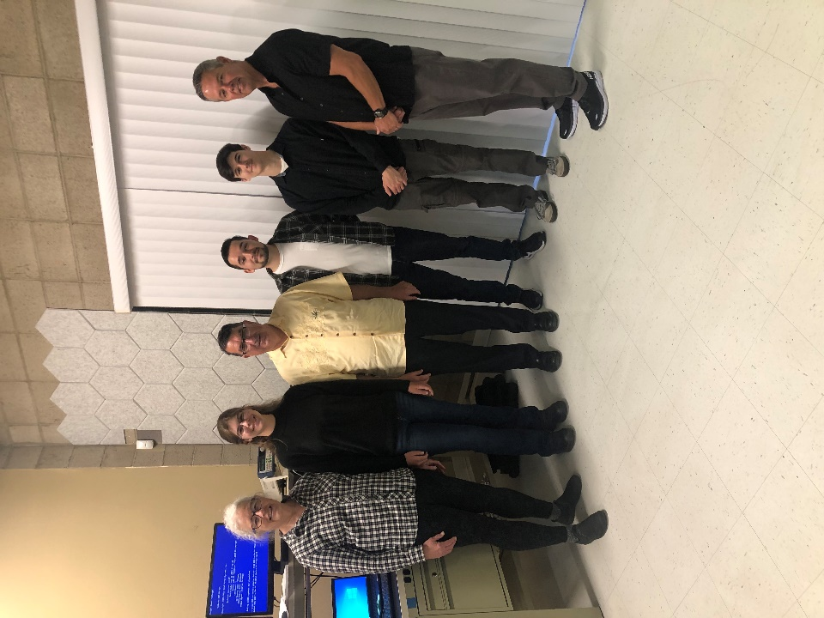
From left to right: Jeanne Cickay (SIL Software Eng. Lead), Teresa Gerrity (Software Eng. Intern), Edmund Burke (SIL President), Flavio Vargas (Network / Compliance Intern), Isaac Jones (IT/Network Lead), Marc Carson AHC Faculty Project Lead. All standing in front of the AFTU system and test station.

Additional Comments:
Overall, the internships and faculty externship were a tremendous opportunity for the selected students and Allan Hancock College. It was an honor to support this important initiative to bolster California’s central coast defense supply chain and future cybersecurity workforce.
Teresa Gerrity stated, “I learned a lot working on the audit trail document about writing technical documentation. This is an area I hadn't had much experience with previously and I will have more confidence in my ability to write software gameplans in the future because of it. I also enjoyed working on the main requirements documentation because it gives a more complete picture of the AFTU's abilities and functions. This context and background really helped me understand the project. The members of the software team were fantastic mentors- either answering my questions directly or helping me track down answers whenever I got stuck on a concept or problem. I also enjoyed the broader topic discussions that didn’t involve software directly, which gave me the opportunity to learn a bit about electrical engineering, GPS receivers, and physics. My internship at SIL was a great learning experience.”
Flavio Vargas stated, “I had an amazing time at SIL, and I certainly hope that this internship opportunity continues into a future job opportunity. Isaac Jones was a great mentor that taught me a lot about what the IT space is, and I know he can certainly continue to teach future interns, I know he certainly needs the help.”

