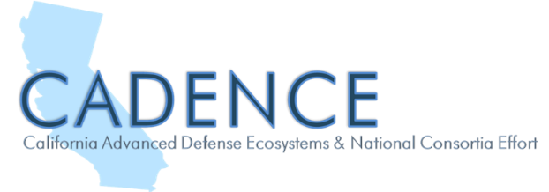
Grant Funded Student Interns and Faculty Externs available to assist California DOD SBIR/STTR Firms with commercialization of dual-use technologies.

The California Community Colleges Advanced Manufacturing Sector is leading a project to place community college student interns and faculty externs with DoD Small Business Innovation and Research (SBIR) and Small Business Technology Transfer (STTR) companies. Student interns coached by faculty from community colleges across California will be matched with SBIR/STTR Phase I, II, & III companies to assist them with commercialization of dual use technologies. The paid student internships (up to 150 hours per SBIR firm) and faculty externships are funded by a U.S. Department of Defense (DoD) grant through the California Governor’s Office of Planning and Research (OPR) called the California Advanced Defense Ecosystems and National Consortia Effort (CADENCE). The Foundation for California Community Colleges (FCCC) acts as the employer of record and handles all the payroll and workers compensation for the student interns.

Eligibility Requirements to Participate in the DoD SBIR Student Internship/Faculty Externship Project:
- Business must meet the definition of a small business by SBA size standards (<500 employees)
- Current or recent recipient of a DoD SBIR/STTR Phase I, II, III Award or 5% of revenues from DoD
- Company must be based in the state of California
- CADENCE project activities will focus on supporting California suppliers in the defense innovation and manufacturing base who are involved in the advancement of specific key technologies or supply chains including microelectronics, fifth-generation (5G) wireless technology, cyber, space, artificial intelligence, and fully networked command, control and communications (FNC3)
FOR MORE INFORMATION, PLEASE CONTACT:  Alan Braggins  STATEWIDE DIRECTOR, ADVANCED MANUFACTURING  alan.braggins@chaffey.edu | 